Docker build
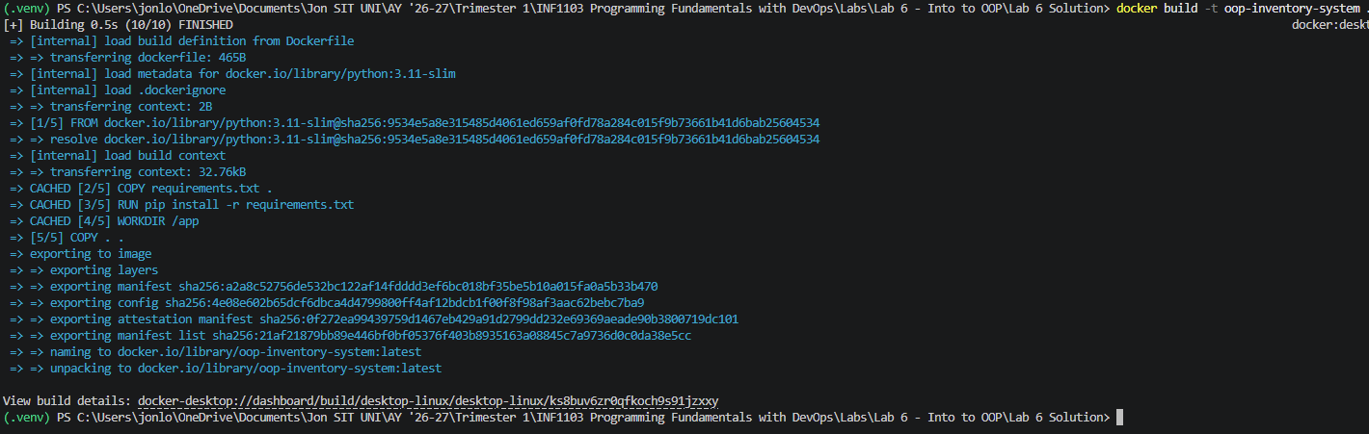

Docker images
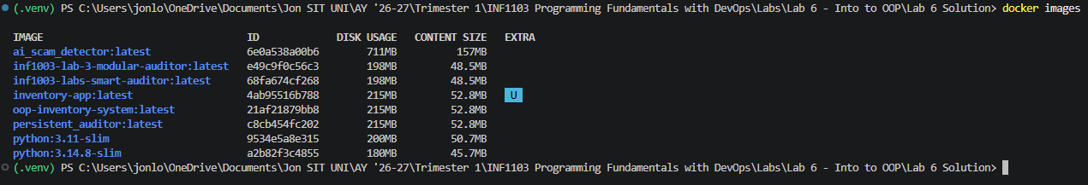

Running the program
